- Go to the website vfwak.org
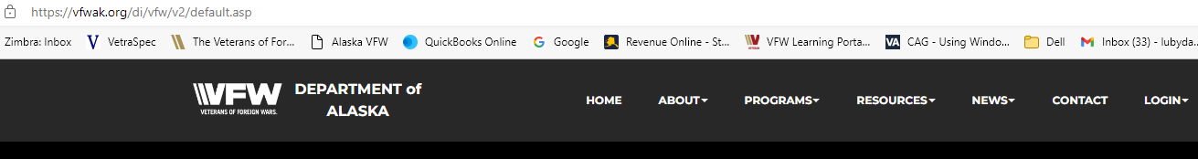

- Under login select Member Only
- Login using your member number (comrades side only) and your password will be your last name.

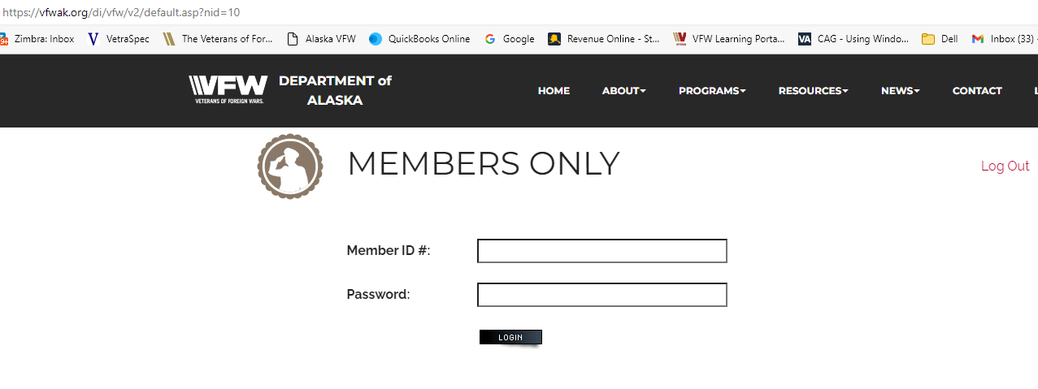
- Select Community Service Reporting
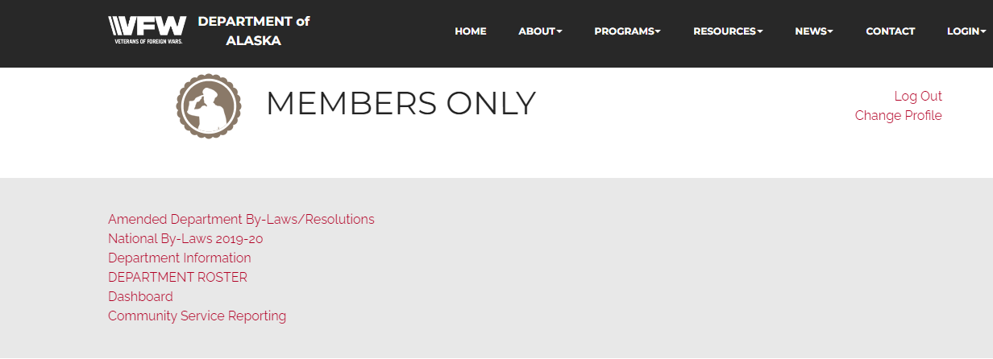

- Here you will enter your community service report information

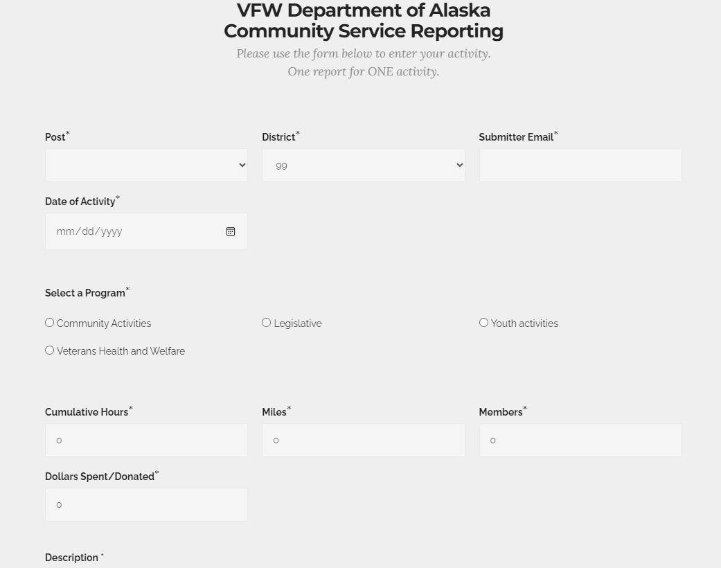

Here is where you will enter your community service activities. Please make sure you are submitting SPECIFIC details on the activities done for the report to be approved. If your report is not approved this is most likely why.

If you have any questions please contact your community service chairperson.

